**FINAL REPORT**

During completion of HW Hillel auto web-site was tested. It was a project which helps to calculate and keep car maintenance expenses. This resource also provides instructions for different car models to repair a car by your own.

Created in Test Rail test cases covered all Requirements concerned to this project which were given by link: (confidential link)

All features of this website were tested:

* Auto List (list of instructions for presented car models)
* Main page of website (it consists of Header, About, Contacts and Footer sections)
* Section with profiles (both user and guest profile)

Testing process was organized in Chrome browser (ver. 96.0.4664.55) and MacOS (ver.11.6).

As for the results of this manual testing most of test cases (60%) were failed. Bugs were not critical, no blockers, but important to pay attention to them. The great amount of bugs concerned the Requirements which ideally should have been reviewed and validation of fields (pop-up Registration and pop-up Edit a profile in User area are the weakest points). Regarding functionality, high attention must be paid to such problems:

* Incorrect work of Restore access pop up which allows to enter any valid email not depending of the status of its registration on the web-site
* Impossibility to change e-mail address of user in Settings (this bug was fixed in working version of website)

All bugs were registered in Jira, link to a project

(confidential link)

Retesting process was provided on working version of Hillel auto website but unfortunately not all found bugs were fixed. For some bugs QA evidence was added.

As for the backend due to Postman app some of scenarios were covered by test scripts, API testing was provided.

To organize Accessibility testing Lighthouse devtool in Chrome was used. For both versions of website (with bugs and working) Accessibility was shown at the level of 78 points, which is not so good. In both cases Garage page with 1 added car to Guest profile was tested. The main problem were:

1. Button “Edit a car” doesn’t have an accessible name, it’s unusable for users who rely on screen readers
2. Links to Header and Footer logo do not have a discernible name that makes worth navigation for the screen reader user.
3. For several elements background and foreground colors do not have a sufficient contrast ratio.

Screenshot for Accessibility testing is below

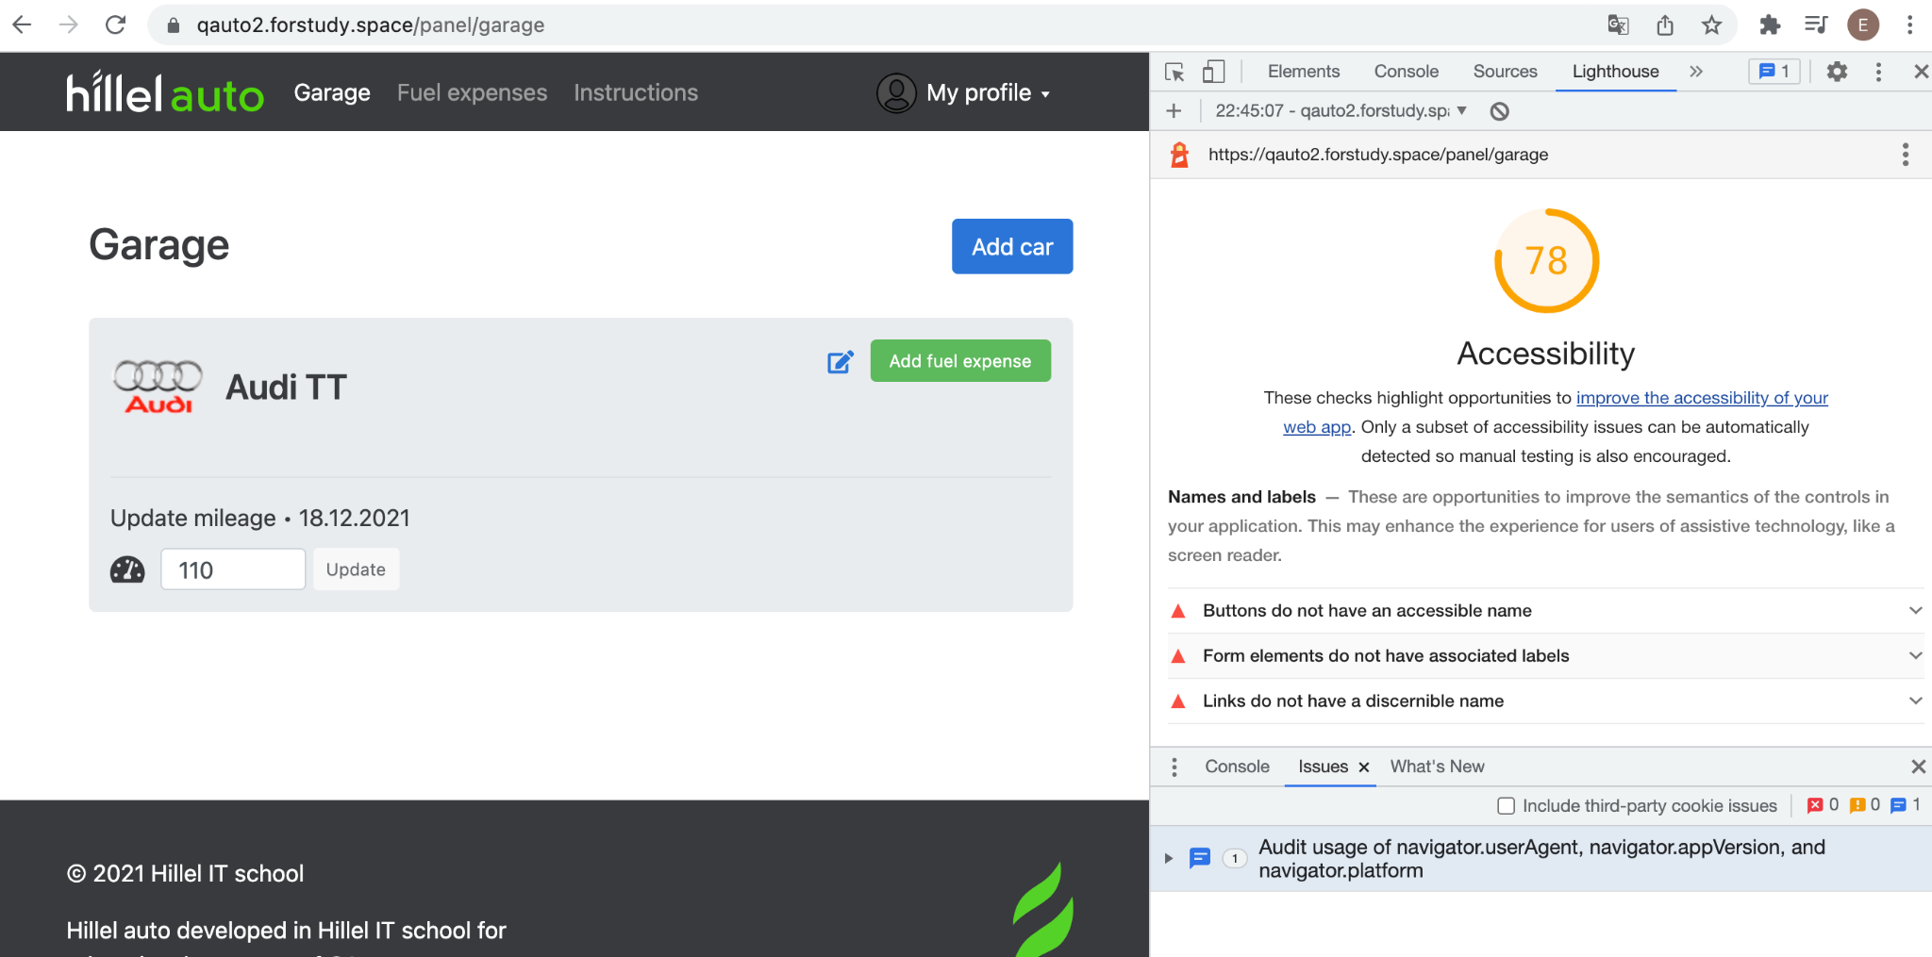

To organize Performance testing resource <https://webpagetest.org/> was used. It shows and estimates page loading at all stages. For both versions of Hillel auto website (with bugs and working) indicators of effectiveness are the same. Results of this testing are attached below:

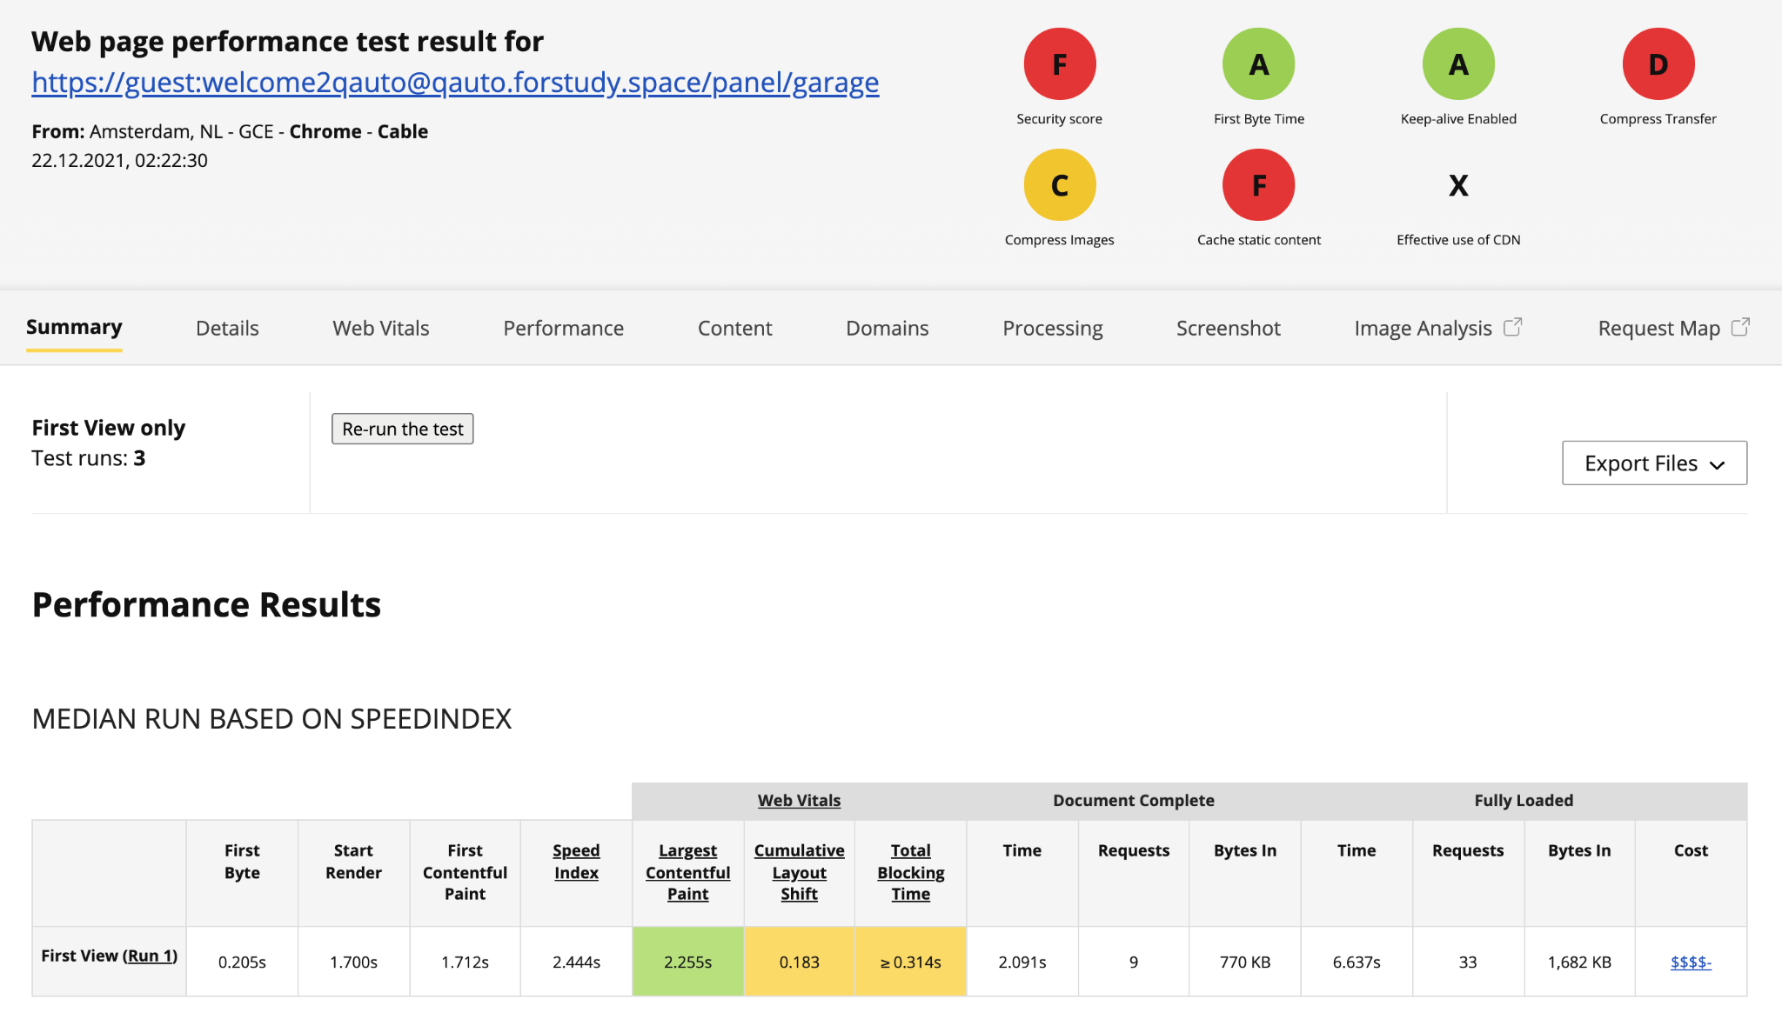

Two of characteristics are in green zone which is excellent result. First Byte Time tells us that server responses fast. Keep-alive enabled allows to use a web-site in a fastest way. The worst situation is with Security and Cache content.

So taking into account all above mentioned there is a conclusion that Hillel auto website isn’t ready to be deployed at Production stage cause Requirements must be reviewed, clarified in some aspects. Not all found bugs were fixed in working version. But this web-site can be shown to a Customer like an intermediate stage of work above the project.